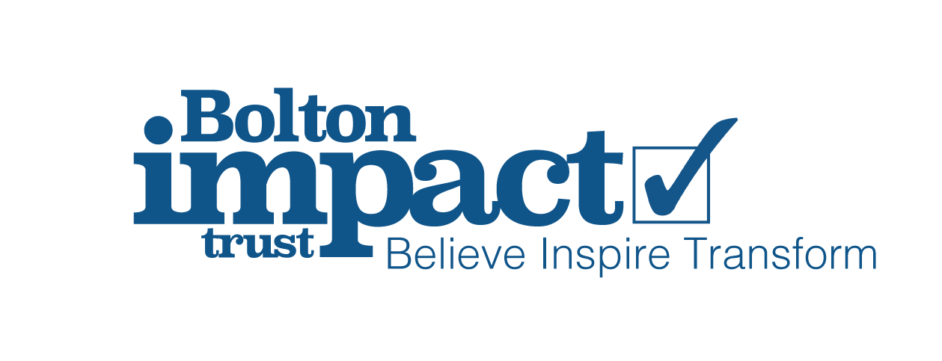

Subject Access Request Form

For the attention of Gill Smith, Data Protection Officer
Bolton Impact Trust
97-99 Chorley Street
Bolton
BL1 4AL

Please provide me with the information about me/my child that I am entitled to under the General Data Protection Regulation. This is so I can be aware of the information you are processing about me/my child, and verify the lawfulness of the processing.
Here is the necessary information:
Name
Relationship with the Trust | Please select:  Pupil / parent / employee / governor / volunteer  Other (please specify):
Correspondence address
Contact number
Email address
Details of the information requested | Please provide me with:  Insert details of the information you want that will help us to locate the specific information. Please be as precise as possible, for example:  - Your personnel file  - Your child’s medical records  - Your child’s behavior record, held by [insert class teacher]  - Emails between ‘A’ and ‘B’ between [date]

If you need any more information from me, please let me know as soon as possible.
Please bear in mind that under the GDPR we cannot charge you a fee to provide this information, and in most cases, must supply me with the information within 1 month.
If you need any advice on dealing with this request, you can contact the Information Commissioner’s Office on 0303 123 1113 or at www.ico.org.uk
Yours sincerely,

